___________________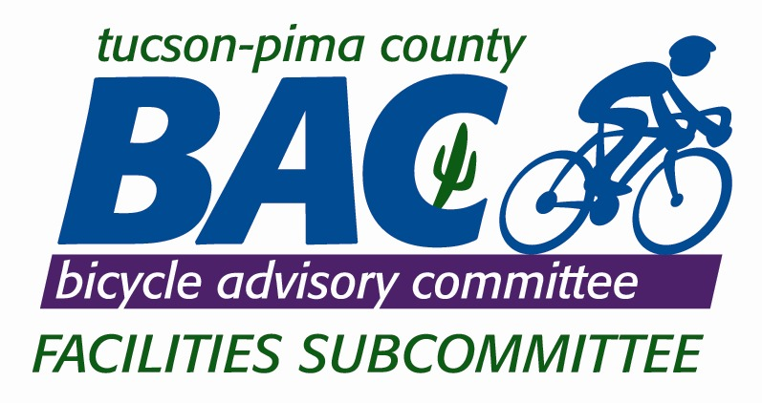___________________________________________________
Pursuant to A.R.S. § 38-431.02, notice is hereby given to the members of the BAC FACILITIES SUBCOMMITTEE
And to the general public that the BAC FACILITIES SUBCOMMITTEE
The following additional meeting will be open to the public:

Thursday May,6th,2010

FACILITIES SUBCOMMITTEE OF THE TUCSON-PIMA COUNTY BICYCLE ADVISORY COMMITTEE (BAC)

The BAC Facilities Subcommittee (FSC) will conduct a meeting Thursday the 6th of May 2010, 11:30 am till 1:00pm at the PBAA, 2609 E. Broadway Blvd. Tucson, Arizona. Discussion and Subcommittee Action may take place on any of the following agenda items:

1. Call to Order / Roll Call (5 min.)

2. Call to public (5 min)

- Review BAC Bike Blvd Recommendation. (15 min.)

- Status ofon list “Low Cost” projects(10 min.)

5. Bike Package #3 status (10 min.)

6. Re Prioritize Lists (10 min.)

7. Construction Standards (15min.)

8. Stimulus Recommendations- Tiger-II(15 min.)

9. Ongoing Projects and Updates. (5 min.)

10. Adjourn

