Bike Church Sanctuary

The first permanent memorial for bicyclists killed on the streets here was installed just north of downtown in the Barrio Anita neighborhood on Friday, August 14, 2009.
For many years, makeshift memorials have been set up along roads: dried flowers, wooden or metal crosses, pictures, and candles. Then white "ghost bikes" started to appear here last year, marking the spots where bicyclists died in traffic accidents. City officials leave those memorials alone unless they pose a public-safety hazard, such as blocking a sidewalk or reducing visibility for drivers.
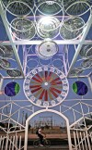
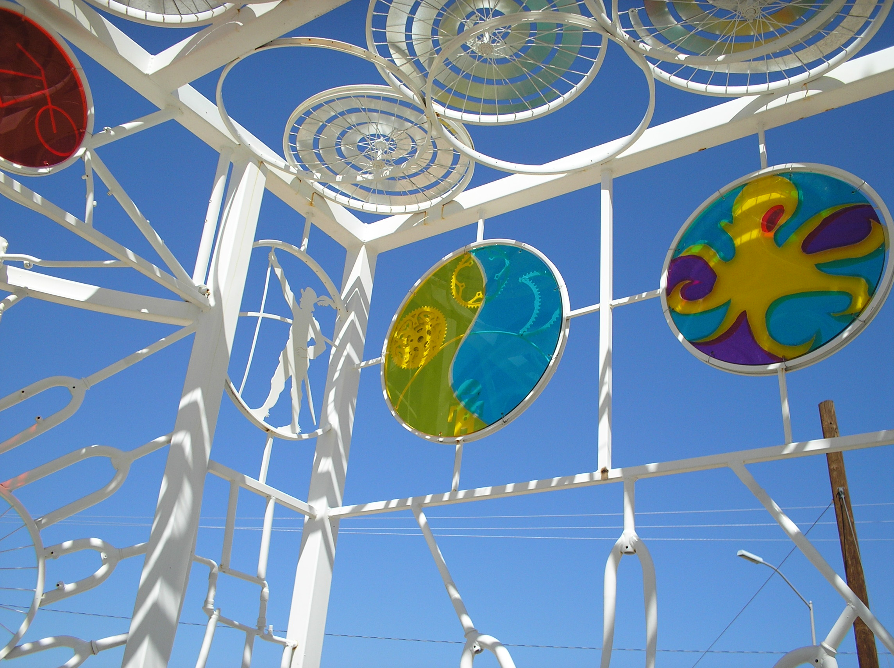
But nothing permanent has marked the lives lost over the years or spread awareness about the cyclists injured or killed.
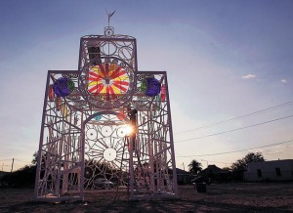
The Ward 1 City Council office, with a $50,000 grant from the Pima Association of Governments and support from cyclists in the region, employed eight students to work on the project with artists Joe O'Connell and Blessing Hancock of Creative Machines. The students worked with O'Connell and Hancock to construct the Bike Church Sanctuary, as it's called, entirely out of bicycle parts.
It's big enough to walk into, and because it's all metal, mementos of cyclists can be attached with magnets. The structure is lighted at night with solar power. It's not just a memorial, and the name isn't meant to symbolize anything specifically religious, but rather "a place to gather and celebrate," O'Connell said. O'Connell and Hancock, worked with the eight students for eight weeks to create the structure.
The structure is on the southwest corner of West Davis Street and North Main Avenue, on city-owned land. It lies along the route of the El Paso and Southwestern Greenway, a planned six-mile bicycle and pedestrian path.

Engraved Commemorative Paver Order Form
Please support the Bike Church Sanctuary concept with a $50.00 donation toward an engraved
commemorative paver. There is a three-line text limit, maximum 13 characters/numbers/symbols/spaces per line. Engravings will be centered. Upper case & lower case may be used. Print clearly—pavers will be engraved exactly as printed below. A notification/tax letter will be sent upon installation.
Line 1 ____ ____ ____ ____ ____ ____ ____ ____ ____ ____ ____ ____ ____
Line 2 ____ ____ ____ ____ ____ ____ ____ ____ ____ ____ ____ ____ ____
Line 3 ____ ____ ____ ____ ____ ____ ____ ____ ____ ____ ____ ____ ____
Name of Donor: ______________________________________________________________________
Address: ____________________________________________________________________________
Phone: __________________________ Email: _______________________________________

This order form with your check made out to Perimeter Bicycling/The Brad Fund and mailed to: The Brad Fund, c/o Perimeter Bicycling Association of America, 2609 E. Broadway Blvd., Tucson, AZ 85716 Information – 520-240-BRAD (2723)

